Terebess Asia Online (TAO)
http://terebess.hu

Evgeny Steiner
Zen Portraits Chinzō: Why do They Look as They do?

(ШТЕЙНЕР Евгений Семенович, 1955-)
доклад на 15-рй конференции «история и культура Японии», РГГУ, Москва, 11-13 февраля, 2012.
In book: Под редакцией: А. Н. Мещеряков: История и культура традиционной Японии 6, Вып. LI. М.: Наталис, 2013. pp. 187-199.

Anstract
This article discusses the phenomenon of ritual portraits of Zen masters (chinzō) and offers an explanation of why they differ stylistically from the similar genres of portraits of patriarchs (sōshizō) and Daoist and Buddhist figures (dōshakuga). The stylistic peculiarity of chinzō which has never been explained in a reasonable way, derives, in my opinion, from their ritual usage and, most of all, ontological status. Chinzō served in the rituals of the transmission of Dharma and substituted the master himself after his demise.

Chinzō (or chinsō, Ch. dingxiang頂相) is one of the genres of Chinese and Japanese medieval painting (and sculpture) which can be described as formal portraiture of Chan/Zen masters. It is known much less than three other main genres of Chinese/Japanese painting associated with Chan/Zen affiliated (or just oriented) artists. The visual characteristics of chinzō portraits precluded their wide appreciation by the Western audience. As for the Eastern (Chinese/ Japanese) audience, they connected chinzō with religious ritual context. All this until recently resulted in a relatively modest quantity of chinzō in museums (the majority are still in temples) and in a rather insufficient research on this genre. The situation began to change in the last years only.
In China, chinzō were known from the Tang epoch, from the 8th century. Unlike the word hiang (Jap. zō 像), which was used as a term for pictorial images, it’s a Chinese Buddhist neologism to translate ushnisha (or uṣṇīṣa頂 – the top of the scull. I shall discuss ushnisha’s relevance to chinzō later). At that time the term referred not only to posthumous painted portraits of Chan masters but more often to sculptures usually made of clay mixed with the ashes of the master himself. (See Adamek 2003, 39)
First chinzō reached Japan around the middle of the 13th century. They were portraits of Chinese Chan masters given to their Japanese disciples. One of them is the portrait of Wuqun Shifan (Jap. Bujun Shiban, sometimes read as Mujun Shihan無準師範, ) executed by an unknown Southern Song artist in 1238 and brought to Japan by his Japanese dharma heir Enni Ben’en 弁円円爾 (1202-80) who founded the Tōfuku-ji monastery in Kyoto where this chinzō is still held.

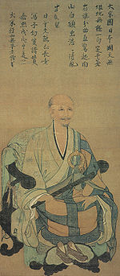 Portrait of Wuqun Shifan

This work is a good example of chinzō (designated as National Treasure), and it is convenient to describe the typical features related to the whole genre using this scroll.
The sitter is shown in a high Chinese armchair (Jap. kyokuroku, Ch. qulu 曲録) sitting turned three-quarters left. The back of the armchair is covered by a brocade. Wuqun Shifan is depicted in a full abbot’s ceremonial garbs: a robe (nōe (Ch. fayi 衲衣), surplice (Jap. kesa, Ch. jiasha袈裟, from Sanscr. kesaya). The parts of the kesa is connected to each other with the big ring, round or sometimes octagonal (Jap. hekikan, Ch. bihuan 璧乾) placed on the left side of the chest over the heart. Wuqun Shifan holds a master’s stick or a scepter (Jap. nyoi, Ch. ruyi 如意). Other implements held in hands in many chinzō can be a fly whisk (Jap. hossu, Ch. fuzi 拂子), a staff (Jap. shujō, Ch. zhuzhang 主丈), a bamboo staff (shippei, Ch. zhubi竹箆) or a whip (Jap. kyousaku, Ch. jongce 警策). His legs are are bend in a lotus position and tucked under the robe. In front of the chair is a small footstool (Jap. tōjō, Ch. tachuang 踏床) with his shoes resting on it.
From the 14th century chinzō painted by Japanese artists began to appear. The earliest signed Japanese chinzō is possibly the portrait of Muhon Kakushin 無本覚心 (1207-1298), who received Dharma transmission from Wumen Huikai (1183-1260), the compiler of the Mumonkan collection of kōans. Kakushin brought the Mumonkan to Japan in 1254, and he was the alleged founder of Fuke-shū sect. His portrait was executed by Kakue 覚恵 in 1315 and belongs to Kōkoku-ji興国寺monastery in Wakayama prefecture.
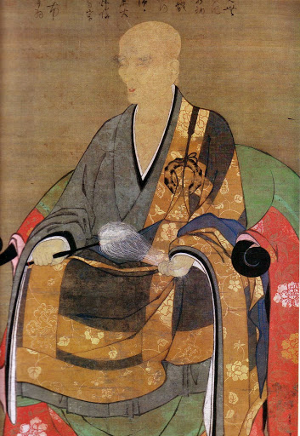Portrait of Muhon Kakushin

Toward the middle of 14th century, Japanese artists produced a number of significant chinzō, such as the anonymous 1334 portrait of Daitō Kokushi 大燈国師 (Daitoku-ji 大徳寺, Kyoto) and the 1349 portrait of Musō Kokushi 夢窓国師 by his desciple Mutō Shūi 無等周位 (Tenryū-ji 天竜寺, Kyoto). And in the late 14th century painter-priests such as Minchō 明兆 (1351-1431) and others produced many first rate chinzō in and for their monasteries.
In total, there are about seventy chinzō designated as National Treasures of Important Cultural Properties, and there are about seven hundred chinzō executed up to the end of Tokugawa period.

In contrast to the monochrome landscapes of that time, the chinzō genre practically did not use expressive modification of nature to emphasize its aesthetic or psychological dimension. All the faces of Zen prelates on these portraits are emotionless, dry, calm and neutral. The outlines are monotonous and even, without any attempts to add some painterly expressivity. This artistic language (resembling snapshot of documents) resulted from the pragmatic function of chinzō – to represent a master’s persona which means a source of Dharma emission. It was also supposed to be a model for disciples during the master’s life, and a sacral object – body substitute – after the master’s death. In this respect portraits chinzō radically differ from portraits nise-e似絵 – a precise, realistic depiction of lay figures (courtiers and samurai) which originated just at the same time when the first Japanese chinzō were made. Although the convenient translation of nise-e is “the likeness pictures,” it’s good to remember that the word nise means “false,” “imitation,” “copy.” In other words, this is the opposite to chinzō, which were also called keshin掛真 – “the hung truth, or reality.”
Let us look at the most famous chinzō, the portrait of Ikkyū Sōjun (1394-1481) made by his disciple Bokusai (d. 1492).
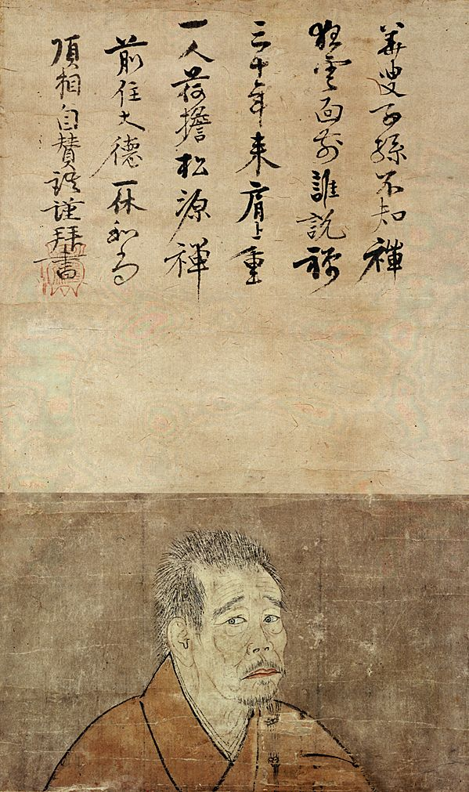
The face in three-quarters and sharp stare convey psychological dynamics and intensify direct contact with an onlooker – or, “the outflow of the master’s spirit,” in the terminology of the Five Mountains.
Let’s discuss this ‘outflow’ in some detail. In recent years, the main meaning of these portraits has been seriously studied with regard to the mystical qualities of chinzō and its ritual usage. The earlier prevailing point of view, according to which a master would present his portrait to a successful disciple as a certificate of enlightenment (or, more precisely, dharma transmission – denbō (Ch. chuanfa伝法), has been declared an invention of art historians that has nothing to do with historical reality. Historians of Japanese religion T. Griffith Foulk and Robert H. Sharf in a series of works claimed the following: “There is virtually no textual or art-historical evidence that portraits now classified as chinzō were ever used in and of themselves as certificates of enlightenment of proof of dharma inheritance. Rather, the wealth of medieval sources at our disposal suggested that the function of such portraits is best understood in the larger ritual context of East Asian Buddhist funeral and memorial rites.”
However, it was not only easily-persuaded art historians but the authoritative Miura and Sasaki who wrote about it. Or, just cf. an inscription on one of the portraits of the influential Chan master Xutang Zhiyu (Jap. Kidō Chigu虛堂智愚, 1183/5–1269): “The succession is now unmistakenly assured.” In addition to this sources I can add never a story never discussed before from the chronicle of life of Ikkyū compiled by his closest disciple already mentioned Bokusai. Ikkyū’s archrival Yōsō Sōi養叟宗頣 (1379–1458), a senior monk who, as Ikkyū himself, studied under the master Kasō Sōdon華叟宗曇 (1352–1428). According to the Ikkyū-oshō Nempu (The Chronicle of Life of the reverend Ikkyū), this not-so-bright Yōsō bragged to his fellow monks about his successful transmission of Dharma that he obtained from the master showing the latter’s portrait as a proof of this claim and a certificate of enlightenment. Under the year 1419 Bokusai placed the following text:

“[Yōsō] Sōi-shuza [Sōi the Principal in the sitting – i.e. the senior monk] asked the old master [Kasō] to inscribe his [Kasō’s] portrait. The last line in Kasō’s poem read: “This will feed the heirs to come”. [Sō]I decided that it was written about him, and began showing the scroll to people and boasting. When the old master heard about it, he got very angry and wanted to burn the scroll. But our master [Ikkyū] told him, “Brother [Sō]I is ripe in age and prominent; he lives here for a long time; everybody knows him here, in the circle of the Teacher. If you burn his scroll now, how would people look at him? If, after the passing away of the Teacher (after one hundred years), [Yōsō] would begin foolishly to show this portrait trying to assure people that it is his certificate, I would definitely expel him.” (Ikkyū-oshō Nempu 1419.

So, it is not the point here that it was not possibly the real transmission certificate as Yōsō claimed. As the author of this text persuades the readers, Yōsō lied twisting the meaning of some ambiguous characters. But the very fact that he tried to pass the master’s portrait inscribed to him, demonstrates that the practice was well established.
These examples demonstrate that the severe criticism of the understanding of chinzō usage as an implement in Dharma transmission and as a certificate of enlightenment (a kind of pictorial inka印可) proposed by Foulk and Scharf is not that absolute and is prone to at least partial correction. What is definitely right in this criticism, is the contention that, to consider only painted portraits as chinzō, would be an incorrect narrowing of this term. Originally, in China, in the period of the Six Dynasties, chinzō were statues venerated not only as icons, but as “real” representations of a deceased master (“body substitutes – not realistic but real,” in Bernard Faure’s formula. This situation is recorded in the same Ikkyū-oshō Nempu: in 1456 Ikkyū organized the creation of a statue of Daiō-kokushi 大応國師 (1235–1309) for his old skete of Myōshō-ji 妙心寺in Takigi and the installment of the completed object there. As a result, “people of Takigi were able to worship [Daiō] as though he was alive.”
Foulk and Sharf wrote about the preceding Chinese practice: “According to the ritual logic of Song Buddhist monasteries a Buddha’s icon, or a living master, or a master’s portrait were interchangeable. It seems that a body of a living master, as well as his portrait, became to be seen as a simulacrum (像 xiang) of Buddha’s nature.” The Chinese concept of xiang (Jap. zō) can be found already in Yijing and Daodejing; it meant a certain mystical creative force that was connected with representation of reality. As early as the fourth century, Gu Kaizhi talked about the “transmission of spirit” through the form, and about “animation” of the form by painting the final dots in the pupils of the eye. Chinese Buddhists used this notion for the rendering of the Sanskrit ushnisha – one of thirty-two features of Buddha. By that, they meant not a visible ushnisha (a protuberance on the top of the head) but an invisible, spiritual one, - the one that could be rendered with the help of a portrait. This is why these ritual images of the masters (three-dimensional effigies or, later, painted depictions) where called chinzō – “the images of the ushnisha. Thus, a portrait was turned into a “vast vessel of Dharma,” according to one Chinese text of the Tang period. In other words, chinzō was not just a portrait or even an icon (icon understood as an image of what cannot be seen). It was a substitute and an embodiment of a master (during his lifetime) and a carrier of his Dharma (after death). An enhanced mystical and dharmic value to a portrait was added through the touch of a master (a sitter, not an artist) – for example, Ikkyū’s hair on his statue in Shuon-an or inscriptions of a sitter on his portrait (for instance, Ikkyū’s calligraphy on the aforementioned portrait of himself painted by Bokusai and in many other portraits.
In other words, the depictions of Chan/Zen masters in chinzō type were animated through the presence of relics. As Bernard Faure wrote, “As religious icon, the portrait was functionally equivalent to the relics, the mummies, or the stupas: it meant the presence of the Buddha in his very absence.” The practice of making images (first rather effigies than portraits) of a deceased master may go back to the Tang era when decaying mummies of venerated patriarchs had to be replaced. Thus the mummy of master Jianzhen (Jap. Ganjin鑒真 or 鑑真, 688-763,), who became patriarch of Ritsu School in Japan, had to be cremated when it began to rot, and an effigy-simulacrum was made in a dry-lacquer technique, ashes incorporated. (It is – now in Tōshōdai-ji monastery in Nara that he founded.)
There was, in all likelihood, another possibility to infuse dharmic energy into portraits of old masters: by way of inscribing them by a living master. This effect (at least in the eyes and minds of the devotees) could produce Ikkyū’s inscriptions on portraits of masters of bygone days: by his touch he “linked up,” or rather, “detonated” their Dharma and turned newly painted images of legendary patriarchs from a “historic picture” to a revealed and operative vessel of Dharma.)
Although such measures as including relics (ashes or hair) into chinzō, or “detonating” Dharma through calligraphy might seem (and rightly so) as a rather speculative practice, the very fact of the existence and ritual use of the chinzō phenomenon tells us that these material object which resembled the master, were needed for the Dharma transmission. Or, to put it more precisely, for better perception and the material witness of the Dharma transmission. Perhaps it would be relevant at this point to dwell a little on the meaning of the Dharma transmission, as I understand it.
Dharma can be described as an energetic – dynamically active – field of non-material substance. It has no relation to god as to a transcendental and metaphysical source of this substance. As the language of description of what I am trying to imply is not yet developed, it can be said only approximately that, in the Buddhist world, Dharma appeared at Buddha’s enlightenment when his consciousness underwent irreversible post-satoric changes. His mind emitted certain thin, sensually imperceptible waves which a few advanced disciples could grasp in the act of a sudden breakdown into the Buddha’s consciousness and could commune with it – commune in a sense of their hitherto separated mental energies interflowing. Let’s recall the smile of Kashyapa and the beginning of the transmission of Dharma. Here it is pertinent to mention again the theory of synergetic anthropology: the ascension of a man through the stages of spiritual practice thanks to his own energetic efforts and to the oncoming stream of energy from an outer source. Going from mind to mind, Dharma was not encapsulated in any individual head (or heart – kokoro) and did not ‘jump’ to an heir upon the death of his master. It existed as a field that transcended the minds and the hearts of all who were within it, but it existed in between individual minds and hearts. I am not sure how the following example is correct from the point of view of physics, but for visual clarity I offer the following image. Let’s imagine individual consciousnesses as lamps with a rare gas inside. This neon or krypton is neither seen nor felt; it does not engage in chemical reactions, but when electric current goes through it, it reacts and flashes out. The neighboring hermetically sealed glass capsule with a rare gas can realize its potential as a lamp when the first one touches it and conducts its electrical charge through it. A chain reaction may follow. At that point, in our picture, we do not have the chief electrician. The illumination (or enlightenment) project does not have a single center and general plan. Let’s suggest instead of that a certain Lichtwollen (if we are allowed to paraphrase Riegl) in our not-yet-lamps and their certain magnetic attraction to the already-lamp. This gravitation can result in accumulation of conductivity – and in a certain moment, due to an unseen touch, a sparkle lights up.
Talking about the depictions of the legendary patriarchs and masters of bygone days I can add here one more observation on Ikkyū’s portraits which can bring us closer to understanding of both chinzō’s pragmatic role and its artistic style. Amongst his numerous portraits executed during Ikkyū’s life, was the one (and chronologically the last one) painted by Soga Shōsen曽我紹仙 (fl. ca. 1523), the third generation of Soga school artists connected with Daitoku-ji. Unlike earlier formal dry and largely unemotional portraits, Shōsen brought the sitter’s features almost to a caricature. Ikkyū’s face is made schematic and grotesque in a great contrast with earlier meticulously drawn depictions. The drawing of the body and the clothes is characterized by the sharp manner of expressive, broad and broken brushstrokes similar to the style of Shōsen’s landscapes. Thus, in painting, shortly before his death Ikkyū moved from the genre chinzō to the genre dōshakuga (‘pictures on Daoist and Buddhist subjects’ which depicted masters and patriarchs of the old days). Conventional and expressive portraits of Rinzai or Daruma in the formal aspect were the complete opposite of dry documentary chinzō, but they coincided with the genre of sansuiga in their painterly, free brush manner. Ikkyū, practically the only one of all the monastic assembly of the Five Mountains, was reckoned among the Chinese fathers of Zen on this visual and formal (and hardly self-reflected) level.
Now a principal question should be posed: why do portraits of masters made as chinzō look so differently stylistically from the depiction of masters made as zenshū sōshizō (禅宗祖師像 – portraits of patriarchs of old days)? The question becomes even more demanding explanation if we recall that portrait chinzō were placed together with this imaginary depictions sōshizō. Placed together – but so different! It has nothing to do with individual styles (or manners) of artists and their specialization. One and the same artist could perfectly work in a dry, meticulous and seemingly naturalistic manner executing a chinzō portrait and use an expressive free brushstrokes depicting a landscape or Daruma. The best example here is possibly the prominent artist Kichizan Mincho 吉山明兆 (1352-1431) – cf. his chinzō of Enni Ben’en in Tōfuku-ji, his portrait of Daruma (Tikotin Museum, Haifa), and his famous landscape “Little Cottage in the Valley Shade” (Kyoto, Konchiin temple).

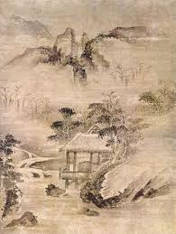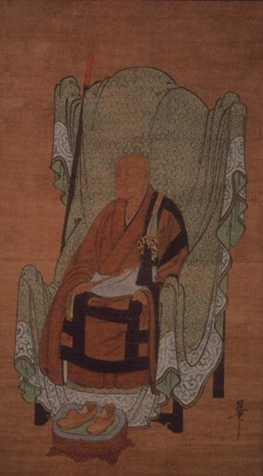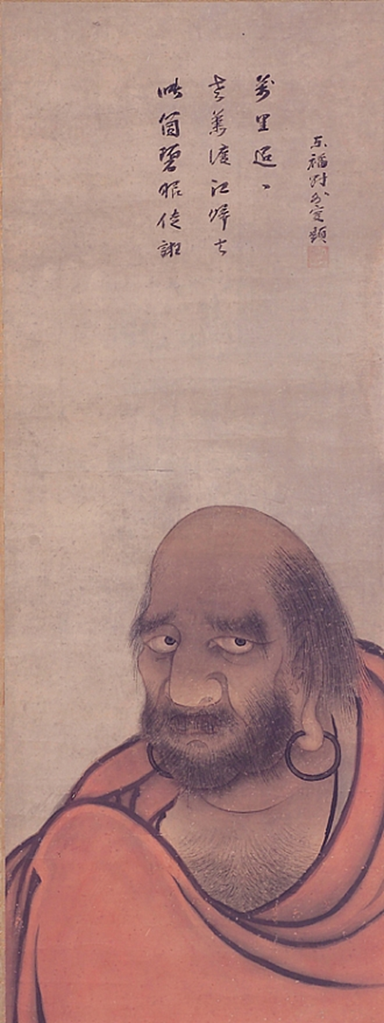

For a non-art-historian audience possibly it is not redundant to stress that an artistic style is not a way of embellishing a depicted image with decorative flourishes, but a means of creation of the aesthetic meaning. In other words, this is the way to show the contents through the form. The choice of a formal style defines the interpretation of the message that is conveyed in the contents. Historians of religion, and authors of recent publications on Chan portraits (Faure, Foulk and Sharf, Adamek) made a great job of reconstructing the original ritual context of chinzō and debunking the pretty musings of art historians about expressivity or the lack of it. But they stopped when it came to interpretation of why portraits of living or recently deceased masters were executed in one manner (dry and linear), whereas portraits of patriarchs and legendary figures of remote times were made in a distinctly different manner (expressive and painterly). “It seems that one and the same artist during the Tang and Song eras could use several different styles,” wrote Adamek, “contrasting types of depictions (a formal portrait and spontaneous Chan subjects) represent an example of complementarity.” But why would one and the same artist employ certain styles in certain situations – and never change them? Possibly, it is because the point is not in complementarity but rather in the fact that, through different styles, there can be formal (visual) differences of different genres within the single corpus of Zen painting – portraiture and historico-mythological. Foulk and Sharf are right in saying that, from the religious point of view, there is no difference between chinzō and sōshizō portraits of patriarchs). But I think they are not correct in claiming that this distinction was established by art historians who introduced the terms “realistic” and “idealistic.” I think it should be taken into consideration that these two types of portrait depictions are distinguished by the different level of historicity or mythicality of the figures portrayed. They also differ in the recipients’ attitude to these depictions: personal and concrete in the case of chinzō versus detached and mythologized in case of sōshizō. With this, concrete and personal, relationship is linked my next thesis, last but not least: a portrait of an elderly living master exuded his personal charisma alongside Dharma, whereas a portrait of a newly deceased one played an important part in funeral rituals and posthumous veneration. The likeness in both cases was close to the audience and well-remembered. Thus the depiction of the facial features required realistic verisimilitude. As for the depiction of Chan patriarchs of bygone days, although their dharmic existence was believed to be still real, the representations of them were not intended for funerary practices and the ‘applied’ verisimilitude was not needed.

Evgeny Steiner is a specialist in 19th-20th century Russian art and in traditional Japanese art. He taught and conducted research in the universities of Moscow, Jerusalem, Tokyo, Yokohama, New York, Manchester and London. Currently he is Professorial Research Associate at the Japan Research Centre, School of Oriental & African Studies, London; member of the Research Forum, Courtauld Institute of Art, London, and Principal Research Fellow of the Russian Institute for Cultural Research, Moscow.
Steiner published about ten books including Stories for Little Comrades: Revolutionary Artists and the Making of Early Soviet Children’s Books (Univ. of Washington Press, 1999; Russian enlarged edition, 2002); Zen-Life: Ikkyu and Beyond (St.Petersburg, 2006; English edition is under preparation); Catalog of Japanese Prints in the Pushkin Museum of Fine Arts, 2 volumes, (Moscow, 2008 – edited, translated Japanese poetry and wrote about 600 entries); Victory Over the Sun, ed. by P.Railing (London: Artists.Bookworks, 2009 – translated trans-rational Russian Futurist texts with commentaries and introduction).
The latest publications: “A Battle for the ‘People’s Cause’ or for the market Case: Kramskoi and the Itinerants”, Cahiers du Monde Russe (Paris), November 2010; “Pursuing Independence: Kramskoy and the Peredvizhniki vs. Academy of Arts”, The Russian Review (USA), vol. 70, April 2011, #2; “The Kitaev Collection of Japanese Art in the Pushkin Museum: Historia Calamitatum”, Impressions (New York), #32 (2011).

Landscape (sansui山水), pictures of Daoist and Buddhist figures (dōshakuga道釈画), pictures of flowers & birds (kachōga花鳥画).
Adamek, Wendy. “Imagining the Portrait of a Chan Master” In Chan Buddhism in Ritual Context. Ed. by Bernard Faure. London and New York: RoutledgeCurzon, 2003, p. 39.
絹本著色無準師範像, 124.5 x 55.2 cm, color on silk, Tōfuku-ji, Kyoto.
First recorded in Azuma-kagami 吾妻鏡 (1241). See: http://www.aisf.or.jp/~jaanus/
Bokusai. The Zen priest Ikkyū-oshō. 43.7 x 26.1 cm. Important Cultural Property. Tokyo National Museum, Tokyo.
See: Matsushita Ryūshō, Ōta Hirotarō and Tanaka Seidai. Zendera tosekitei. Genshoku Nihon no bijutsu 10. Tokyo: Shōgakkan, 1967. Pp. 199-200; Fontein, Jan and Money L. Hickman. Zen Painting and Calligraphy. Boston: Museum of Fine Arts. 1970. Pp. xxx-xxxi; Kawakami Mitsugu and Yoshikawa Matsu, eds. Zenshū no bijutsu:zen’in to teien. Nihon bijutsu zenshū . Tokyo: Gakushū kenkyūsha, 1979. Pp. 165-66; Stanley-Baker, Joan. Japanese Art. London: Thames & Hudson, 1984. P. 113; Brinker, Helmut. Zen in the Art of Painting. Translated by George Campbell, London and New York: Arkana, 1987. P. 147 and many others.
See: T. Griffith Foulk, Robert H. Sharf. “On the ritual use of Chan portraiture in medieval China”. In Chan Buddhism in Ritual Context. Edited by Bernard Faure. L. and NY: RoutledgeCurzon, 2003, p. 76.
Ibid., p. 75.
See: Miura, Isshu and Sasaki, Ruth Fuller. Zen Dust: The History of the Koan and Koan Study in Rinzai Zen. Kyoto: First Zen Institute, 1966, pp. 196-97
Daitoku-ji bokuseki zenshū: Daitō Kokushi roppyaku-gojūnen daionki kinen shuppan. Maruoka Muneo hen. Tokyo : Mainichi Shinbunsha, 1984-86, 3 vols. Vol. 1, pl. 10, p. 20 (photo); transl. Norman Weddell, p. 300.
Ikkyū-oshō Nempu, 1419. Published in: Kyōunshū, Kyōunshishū. Jikaishū. Ed. Nakamoto Tamaki. Tokyo, 1976. 狂雲集; 狂雲詩集; 自戒集。 中本環編著、 東京: 現代思潮社, pp. 384-85.
Evidently, Bokusai, as Ikkyū’s biographer, approached the task of Yōsō’s disavowal very seriously. Doing so, he could not avoid some forced arguments. The line, “wrongfully interpreted” by poor Yōsō, could be interpreted by him quite correctly after all. The first character in Kasō’s poem, which Bokusai presented as “feed,” “nourish,:” sounds and writes as the semantically principal character in Yōsō’s second monastic name Sōi (頤 i). Exactly by the same character Yōsō is referred to in his (Bokusai’s) own text. (Ikkyū, by the way, often was referred to as Jun – omitting the character Sō, common for many monks of this school.) Consequently, it is hardly possible to exclude the possibility that Kasō meant something like “[Yōsō Sō]I will come and nourish the heirs.” One way or another, however late Yōsō was awarded his inka, he soon became the chief abbot of Daitoku-ji for a five-year term, and later for another seven. Recently the most authoritative commentator of Ikkyū’s Kyōunshū, Hirano Sōjō, a Daitoku-ji priest himself, wrote quite forthrightly: “From the formal viewpoint the single legitimate heir of Kasō was Yōsō.” Ikkyū-oshō zenshū. V. 1. Kyōunshū. Ed. Hirano Sōjō. Tokyo: Shunjūsha, 1997; 一休和尚全集。第1卷。平野宗浄編著。東京: 春秋社。P. 116.
Cf. what authoritative resource JAANUS writes: “Inka 印可. A portrait given by a master to a student as a certificate of the student's attainment of spiritual awareness and as a symbol of the clear and unbroken lineage of a sect. These portraits often include hōgo 法語, or words of religious enlightenment, inscribed by the priest depicted. A portrait done in a realistic and detailed style, together with an inscription, provided the disciple with both the tangible presence and the inspiration of the teaching of his master long after personal relations were severed through parting or death.” http://www.aisf.or.jp/~jaanus/
Faure, Bernard. The Rhetoric of Immediacy: A Cultural Critique of Chan/Zen Buddhism. Ptinceton: Princeton University Press, 1991. P. 170.
Ikkyū-oshō Nempu, 1456. In: Kyōunshū, Kyōunshishū. Jikaishū. Ed. by Nakamoto Tamaki. Tokyo, 1976. P. 392.
Foulk & Sharf , op. cit., p. 117.
See: Adamek, Wendy. “Imagining the Portrait of a Chan Master” In Chan Buddhism in Ritual Context. Ed. by Bernard Faure. London and New York: RoutledgeCurzon, 2003, p. 65.
Faure, Bernard. “Chan and Zen Studies: The state of the field(s)”. In Chan Buddhism in Ritual Context. Ed. by B. Faure. London and New York: RoutledgeCurzon, 2003, p. 17.
It is relevant to recall here that Bakhtin indicated that an indispensable condition of all dialogic communication was the constructive presence of the third. This tacit third can be the collective consciousness which, knowingly or not, for the author of text, represents a certain higher level of ideal understanding. At that, points out Bakhtin, “the said third is not something mystical or metaphysical (although under a certain worldview it can be understood like this). It is a constitutive moment of the whole proposition that can be detected at the serious analysis.” (Бахтин М.М. Эстетика словесного творчества. М.: Искусство, 1979.(Bakhtin, Mikhail M. The Aesthetics of Literary Creation), p. 306.
The rationalization (and at the same time mythologization) of the idea of this outer source of energy had been vividly expressed in Jingde Era Transmission of the Flame (1004). The origin of transmission there goes back to Seven Buddhas of the past (and of other worlds) who preceded Shakyamuni. The first in the line was Vairochana (J. Dainichi) – the emanation of the great light! Possibly, it is this light that, transmitted from ancestors (or patriarchs – so祖) to heirs, provoked their enlightenment. See more on transmission: Bodiford, William M. “Dhrama Transmission in Theory and Practice” // In Zen Ritual: Studies of Zen Buddhist Theory in Practice. Ed. by Steven Heine and Dale S. Wright. Oxford: 2008. pp. 261-282; Штейнер, Евгений, «Сатори, природа будды, дхарма: как это соотносится с сознанием и что делает с последним дзэнская практика» // Точки/Puncta 1-4 (2008), pp. 181-218. (Steiner, Evgeny, “Satori, the Nature of Buddha, Dharma: How All This is Connected with the Consciousness, and What the Practice of Zen does with the Latter” // Tochki/Puncta 1-4 (2008), pp. 181-218); Штейнер Е.С. «Дхарма и дзэнская практика ее обретения и передачи // Фонарь Диогена: Проект синергийной антропологии в современном гуманитарном контексте. Ред. С. Хоружий. Москва: Прогресс-Традиция, 2010. (Steiner, Evgeny, “Dharma and the Zen Practice of its Reception and Transmission // Diogenes’s Lantern: A Synergetic Anthropology Project in the Modern Humanitarian Context. Moscow: Progress-Tradition, 2010, pp. 479-521.
Two years after I wrote the above lines, I read a somewhat similar imagery used for the description of transmission in Japanese medieval art and literary schools: “It is doubtful whether we will ever have the means, or the patience, to lay bare the whole picture of this chaotic world of mediaeval secret transmissions. I imagine it as a tangle of live wires, where new ideas and practices flew like sparks from one circuit to another, seting off instantaneous, unpredictable chain reactions, triggered by historical circumstances that <…> are no longer accessible to us. In its endless complexity, this world of secrets will probably continue to defy our powers of analysis and understanding, but at least the mass of sources that it produced allows us to discern some of its structural characteristics, and gives us a taste of the bold imagination and relentless energy that pervaded this medieval realm.” (Teeuwen 2006, 198)
More so after his death: see Ikkyū’s expressive portrait by Kanō Tan’yū in Shinju-an, executed a century-and-a-half later with only black ink. Possibly it is a sketch only. (See Daitoku-ji / Nihon koji bijutsu zenshū. V. 23. Tokyo, 1980. 大徳寺。日本古寺美術全集.1980, ill. 77).
See: Adamek, Wendy. “Imagining the Portrait of a Chan Master” In Chan Buddhism in Ritual Context. Ed. by Bernard Faure. London and New York: RoutledgeCurzon, 2003, pp. 41 and 44.
See Foulk & Sharf . Op. cit., p. 129.

